**Case SMES**

*(version 1.0, October 2012, S. Angelov)*

**Foreword**

The case is based on a real Dutch company. For confidentiality reasons, the company name was changed into a fictitious name - SMES. For educational reasons, the case is simplified and at a number of points adapted.

**Introduction to the case**

SMES is a Dutch company focusing on designing and constructing advanced vessels and equipment for the specialist maritime sector. It is a major player in the global market for dredging and mining vessels and equipment, and an international market player in the field of custom build ships and supplies for offshore construction. The company’s customer base includes dredging operators, oil and gas corporations, offshore contractors and government authorities, for who SMES’s products are vital for business.

SMES consists of 34 Business Units (BUs), which are clustered in the three divisions Dredging, Offshore and Technology. Each division serves its own market. Furthermore, the BUs operating in the Technology division fulfill also an important internal supply and support function for the other companies of the SMES group, as depicted below.

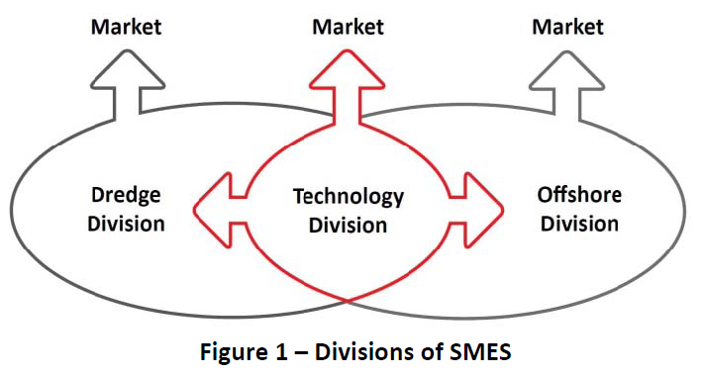

The organizational structure is a matrix structure with twelve different Product Lines (PLs) and twelve different areas. Each PL offers a different part of the product portfolio and serves a specific market within either the dredging or the offshore market. Each PL is responsible for every aspect of the products it offers in all areas, covering the complete life cycle of these products. This implicates that within its portfolio, the PL is responsible for sales, results, marketing, product development, design, cost estimation, production and technical support (TS). Each Area Manager is responsible for sales and margins of new build activities in a specific region, covering all PLs. The PLs make use of shared resources for technology, production and the BUs in the Technology division.

To address the goals of the assignment (see opdracht.doc), only part of the information on SMES is relevant. Below, the known information from SMES relevant for the assignment is presented. Note that although all information below is relevant, at a number of points it is not complete (no employee was able to provide the needed information).

**Relevant organizational units and roles**

**Relevant organizational units**

We focus only on the dredging division and only on two of the PLs related to the dredging division, i.e., PL - Standard Hoppers and PL – Custom Built Hoppers. PL - Standard Hoppers is responsible for the complete product life cycle of standard hoppers. PL – Custom Built Hoppers is responsible for the complete product life cycle of custom built hoppers.

The PLs form the core of the organization as they are responsible for their product segment, in terms of turnover and results. The other units fulfill a relevant function for the PLs. The supporting units are grouped in two general BU – SMES New Build and SMES Components. We focus on the following units relevant for our PLs.

Area Management is responsible for all sales activities concerning new build vessels. This means that the PLs depend on the Area Management for the sales of new build vessels. SMES Head Quarter is one of the business units in Area Management. It is responsible for sales of new build vessels. Naturally, Area Management is part of SMES New Build.

The warranty service is fulfilled by the Warranty department of SMES New Build. Warranty has two subdepartments i.e., Project Management and Field Service.

Furthermore, the PLs depend on SMES Components for the sales of new build dredge parts and for the sales in the aftermarket. SMES Components is a business unit which offers dredge installations and dredge components to the PLs for new build vessels, and offers spare parts and services directly to the external customers. SMES Components is composed from a number of departments: External Sales, Sales Support, and Operations. External sales has six LSOs (Local Sales Offices), which are local sales and services offices. In order to simplify the case we discuss only LSO India. Technical Support (TS) is responsible for the execution of service jobs and a sub department of the department Operations.

For some legacy and legislative reasons although the PLs are supported by SMES New Build and SMES Components, PL - Standard Hoppers and PL – Custom Built Hoppers reside (organizationally) within SMES New Build.

**Relevant roles from PLs**

The only roles within the PL that are involved in the case are:

*PL Manager*: PL Manager acts as a secondary salesman for new build vessels, who determines the contractual terms and the price. He comes in the picture when the functionality and technical design need to be discussed.

*Marketing Manager*: Marketing Managers are responsible for marketing activities.

In the sales planning process, the PL Manager and the Marketing Manager support the Area Manager in the setup of the annual sales plan.

**Relevant roles from Area Management**

*Area managers*: Area Manager fulfill a central role in the sales activities related to new build vessels. Each Area Manager operates in a specific region and is the first contact towards the customers in his region. Their primary job is to identify sales opportunities and initiate customer contact. Besides that, their job is to redirect customers to the appropriate BU for products other than new build.

*Central Sales Office employees*: The Central Sales Office Employees take chart of all the administrative tasks related to the activities of the Area Management.

*Agents:* Agents are local, external representatives looking after the interests of SMES and are indispensable for the organization. An agent speaks the local language, understands the culture and politics in the region and knows the local market. Furthermore, his local network of contacts, such as representatives of ministries, can be of great added value. He generates leads, accompanies customer visits, and follows up on customer visits.

**Relevant roles from Warranty**

The relevant roles fulfilled within Warrantyare:

*Project Leader Warranty:* The Project Leader Warranty is responsible for the settlement of claims concerning a new build vessel.

*Field Engineer Warranty:* The Field Engineer Warranty executes service jobs during the warranty period of a ship.

**Relevant roles from SMES Components**

*Local sales manager (LSM):* The LSM is responsible for the total sales of in the aftermarket (spare parts and services) in its region.

*(key) Account Managers:* AM support the LSM, by being the first contact for a specific group of customers within a specific region. Besides that, SMES Components has for its most important customers Key AM (KAM) who are responsible for the total sales of in the aftermarket (spare parts and services) for a specific customer.

*Technical Account Manager (TAM):* TAMs fulfill a technical consultancy role for the customer and are a customer’s first contact for technical issues. They closely cooperate with the (K)AMs and regularly visit the fleet of the customers. Their job is to identify leads and initiate follow up.

*Sales Support Employee (SSE):* SSEs have an administrative role. They support the LSMs and (K)AMs by coordinating and processing the RFQ and RFO. SSEs operate within the LSO (SSE India) or from the central office in The Netherlands (SSE - Netherlands).

*Project Manager TS:* Managers TS are responsible for the execution of paid service jobs, supporting the commissioning of new build vessels and the settlement of claims.

**Relevant products and services**

The product portfolio of SMES can be separated into two main categories: new build products and after sales products. New build products include vessels and parts for vessels. After sales products include spare parts and post-warranty services. We do not focus any further in the specific types of products as they are not relevant for the assignment.

**Relevant customer-related processes**

For both new build (vessels and parts) and after sales (spare parts and services), the sales process is in general the same. First sales planning is done, then customers are visited (a preparation before the visit has to be done), then lead management is performed, then offers are made to the interested clients, then an order is received from the client, the product is designed (if needed) and produced. Warranty and customer support related activities follow the production.

Below, these general activities and the relation with the SMES products, services, and roles involved in them are explained. Note that these processes span across multiple units and departments and employees from these departments are involved in it.

**Sales planning process**

*(this sub-process is performed at new build vessels and after sales)*

Yearly, all Area Managers, LSMs, and KAMs, write a sales plan for the next year. These plans include a thorough analysis of the market, including aspects such as trends in the market in the area or region, SMES’s market position, competitor analysis, customer profile and customer’s investment plans.

Firstly, all relevant data is collected. Then it is analyzed. On the basis of the analysis the new plan is written down. The plans are sent by email to other sales representatives on a need-to-know basis.

**Visiting customer process**

*(this sub-process is performed at new build vessels and after sales)*

Sales representatives (TAM, KAM, LSM, Area Managers, PL Managers) visit their customer(s) periodically. The reason for a visit can be a customer request to come by, to follow up an important lead (as part of the overall sales process), or because it has been a while since the last visit (thus, this subprocess can be executed also separately from the sales process). Before the visit, a preparation has to be done. The preparation activity is complex and is a process on itself (discussed below). Then the actual visit takes place. After the visit, the sales representative summarizes the most important findings in a visit report, which is then sent by e-mail to other sales representatives on a need-to-know basis. In addition to distributing the report, the sales representative initiates follow up actions (a list of tasks) that have to be done by Sales support employees and Agents on the issues raised by the customer during the visit. The sales representative monitors how these tasks are performed by the respective employees and when they are completed communicates the results to the customer.

**Preparing visit to customer process**

*(this sub-process is performed at new build vessels and after sales)*

In order to have a comprehensive view of all ongoing matters regarding this customer, the AM (or KAM) gathers all relevant information on the concerning customer prior to the visit. He/she collects quotation information (what the current company quotations are), checks the client for outstanding payments, collects the status of the client’s existing orders, checks for outstanding claims and complaints. These activities are not performed in any specific order but they must be all completed before the customer can be visited.

**Lead management**

The lead management process for new build activities concerns the follow up of signals indicating that existing customers are planning to extent their fleet or to replace one or more vessels, and signals indicating that a new player is planning to enter the dredge market. By following up these signals, area managers hope to receive a new RFQ. Because of its very unstructured nature this subprocess is not specified in separate activities.

**Offering**

*(this sub-process is performed at new build vessels)*

The offering process for new build vessels describes the steps to create and send a quotation to the customer concerning new build vessels. The process starts when a new RFQ (request for quotation) is received. Next, the Central Sales employee decides whether the RFQ should be accepted. If the request is refused the customer is informed by the Area manager and the process ends. If the request is accepted, the Area manager prepares a quotation and negotiates the quotation with the customer. If the customer is not satisfied with the quotation, a new quotation will be prepared and again discussed. This is performed until the customer accepts it or the Area manager decides to stop the iterations. If the customer accepts it, the contract negotiations start. If the negotiations proceed successfully, the contract is signed and a new sales order is created.

**Offering**

*(this sub-process is performed at after sales & new build parts)*

It specifies the offering process for new build parts and after sales - the steps to create and send a quotation to the customer concerning parts for new build vessels, spare parts, or service activities. The offering processes for new build vessels and for new build parts and after sales are executed by different departments, which have different systems in place to support these processes. This sub-process is also slightly different for after sales and therefore is separately described. The process starts when a new RFQ (request for quotation) is received. The first task for the KAM or LSM is to determine if the customer is blacklisted on the market. By negative outcome the customer is informed about it and the process stops. By positive outcome, the customer is checked if it is new to SMES. If it is new, the customer is checked/screened. By negative outcome the customer is informed about it and the process stops. If the outcome is positive (or it is an existing customer) the request is verified. Again, by negative outcome the customer is informed about it and the process stops. By positive outcome, a quotation is prepared and sent to the customer. If the quotation is rejected the process stops. If it is accepted a sales order is created.

This process can both be executed at the central office of SMES Components in The Netherlands, or at one of the LSOs.

**Claim settlement**

*(this sub-process is performed at new build vessels)*

The claim settlement process addresses the warranty service step and shows the course of the settlement of submitted warranty claims. The warranty period of a new build vessel is one year, allowing the customer to get failing components on board of the vessel repaired or replaced at the costs of SMES.

The process starts with a new claim that comes to SMES. The claim is registered by the Project Leader Warranty. It is checked and if it is inappropriate the customer is informed that the claim is rejected, the claim is closed, and the process stops. If it is appropriate, a solution is determined and is discussed with the customer. If the customer doesn’t agrees with it, a new solution is elaborated and discussed. If it is accepted, the solution is applied, a service report is written and the claim is closed.

**Complaint and claim management**

*(this sub-process is performed at after sales & new build parts)*

The complaint and claim management process for new build parts & after sales refers to both

the warranty service phase (for the settlement claims) and the customer support phase (for dealing with complaints).

Complaints and claims can come from customers directly, or, if it concerns a claim regarding a component on board of a new build vessel, it is received from Warranty. When it is received, the Sales Support Employee labels the claim. If the claim is about a process, the KAM/LSM informs the customer on the measures that will be taken to resolve the complaint/claim. Later, the SSE asks the customer if the resolution is satisfactory. If the complaint is product related, the Product Manager TS checks if the complaint is appropriate (inappropriate ones are rejected and the customer is informed by the respective KAM/LSM). If it is appropriate, the Product Manager TS executes the work that is needed, writes a service report, and finally, the SSE checks the customer satisfaction.

**Customer support**

*(this sub-process is performed at new build parts & after sales)*

The customer support process describes the response to any customer request that is not a RFQ, complaint or claim. Examples of request handled by this process are questions regarding an invoice, a request to send a product manual or product certificate and questions regarding drawings or bill of materials. The execution of this process is the responsibility of the Sales Support department in The Netherlands. In order to respond appropriately to the customer request, the support of other departments is frequently required. Because of its very unstructured nature this subprocess is not specified in separate activities.

**Relevant software applications at SMES and their users**

At SMES currently use a number of applications that are related to the discussed business units.

They have two ERP systems.

The first one is called HARP and is used at SMES Components. This system supports the processes for new build parts and after sales, if the process is executed in The Netherlands (more specifically, the system is used in the sales planning activities, the preparation of visits to customers, the offering process, and the customer support process). However, in the Indian office, the offering process is executed manually without the support of a system. Quotations and orders are processed by office application systems and stored on the local network drive. The HARP system has three major components, i.e., Ordering, Workflow management, and Reporting. The ordering component is used to create quotations and sales orders. The workflow management component supports the coordination of processing quotations and sales orders. The reporting component can be used to run different kind of analyses, for example sales order analyses.

The second one is called SMART and is used at SMES New Build. SMART is used to support the offering process.

Each of the two units (SMES Components and SMES New Build) make use of two separate but equivalent accounting systems: Accountview SMES Components and Accountview SMES New Build.

An accountview application has two major modules: reporting and accounting. Accountview SMES New Build and Accountview SMES Components are used in the preparation subprocess of visiting customer process (to collect relevant client financial information).

Two systems aimed specifically for the storage of specific data are in place (thus, they are DBMS augmented with the needed user interface to use them):

* SMES Components complaint DB is used to register and store customer complaints (at new build parts and after sales). In the Lead management process data is read from this system, and in the Complaints and claim management process data is created and read.
* Claim Registration Program (CRP) is a database developed by Warranty to register claims. It is used in the Claim settlement process.

Another tool - Hyperion is used to perform data analyses. Hyperion is a typical OLAP tool. It is used in the Sales planning process at new build parts and after sales.

An application called “Intranet” by most employees is used to securely share information among people (the application can be compared to SharePoint). It is mostly used in the preparation to customer visits subprocess. MS Outlook is generally used as a personal information manager system. Its role is most notable in the visiting customer process. The last tool is called ii‐Desk. It is a web‐based application used by Warranty to plan the service engineers (involved in determining the solution and in executing it).

Some of the applications can interoperate with each other. Accountview SMES Components can make use of two services of HARP offered through its interfaces. The journal entries in HARP, that represent the amount of money a customer has to pay for a sales order, are imported by Accountview, which processes the transactions. In this way, the money transactions are automatically related to the sales orders created in HARP. This enables the reporting component of Accountview to generate overviews of the status payments of the sales orders in HARP. Accountview contains no customer database and therefore, basic customer information, such as the customer ID and customer name, is imported from HARP, in which the customer database of SMES Components is maintained. The Accountview SMES New Build makes use of the same two services by the SMART system. The Hyperion system can make use of the data in any system (after some tuning within Hyperion).

The following table describes which roles discussed earlier have access to the systems.

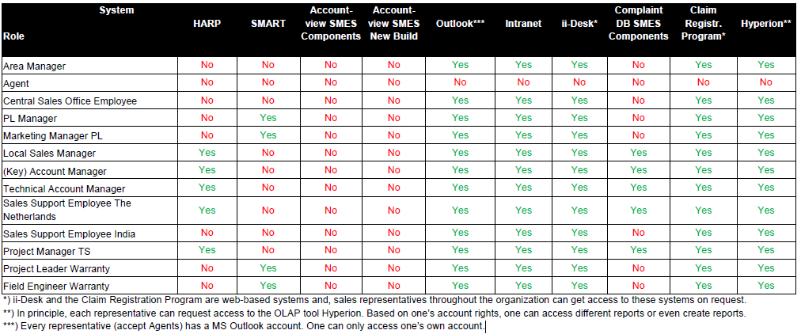

**Relevant infrastructure and technology at SMES**

All systems at SMES are installed on MS Windows platforms. The claim registration program and ii-Desk are web-based which means that besides the high volume of transactions and data storage that they have to support, they are coupled with a web server.

CRP and SMES Components complaint DB reside on two dedicated machines (kit-kat, and twix) which are optimized for high performance and equipped with large storage capabilities. Furthermore, the data is backed up every night on two other, separate machines (slower but robust) called CP1 and CP2.

Similarly, HARP and SMART run on two separate systems (Zeus and Mars) which were at the time of purchase high performance and with large storage volumes. As HARP and SMART are ERP systems, besides they huge size (each of them is about 7 GB), they maintain internally extremely large data volumes. At present Mars is almost out of free memory.

MS Exchange server is installed together with the Intranet application on a machine called DeelPunt.

Hyperion is installed on the same machine (Garfield) on which also ii-Desk operates. This has led to multiple complaints about the responsiveness and performance of these two systems.

The distributed nature of the company (with a headquarter in Netherlands but with eleven area branches) means that some of the applications are installed at the headquarters but need to be accessed from the area branches. Per branch there is local area network and between branches communications take place over the Internet. Communications outside a branch always go through a firewall and the standard equipment used nowadays in companies for coupling an intranet to Internet.